
ENVSCI704 Tender Report

Coastal Erosion Modelling of Buffalo Beach in Whitianga, Coromandel

Tender #3 | RFx ID: ENVSCI704
Submitted to: Thames-Coromandel District Council Procurement Team
Submitted by: Peta Koloamatangi (686891371)
University of Auckland

Submission date: 12 October 2026


Executive Summary
This report assesses historical shoreline change at Buffalo Beach, Whitianga, and projected retreat associated with sea-level rise (SLR) to support Thames-Coromandel District Council’s coastal hazard and adaptation planning. Historical analysis indicates a mean erosional trend of −0.190 m yr⁻¹, with the greatest erosion at Transect 20 and accretion at Transect 41. SLR sensitivity modelling identifies Transects 6–8 as particularly susceptible to retreat, with Transect 7 showing the highest estimated sensitivity at approximately 67 m per metre of SLR. Projections are indicative because of data uncertainty and simplified model assumptions. Further site-specific assessment is recommended to inform coastal management and long-term adaptation.

Introduction

This report assesses historical shoreline change at Buffalo Beach, Whitianga, and projected retreat associated with sea-level rise (SLR) using MATLAB. Historical trends, seasonal and interannual variability, and future projections are analyzed to identify spatial differences in shoreline behavior and potential coastal vulnerability. The findings provide an initial evidence base for Thames-Coromandel District Council’s coastal hazard assessment, land-use planning, and adaptation decisions. Projections are indicative and should be supported by further site-specific investigation.

Data and analytical methods
2.1 Data inventory and quality assessment
The dataset was obtained from the Coast and Ocean Collective platform. It contains 338 shoreline survey dates from 1999 to the latest observation in the Intersects sheet, with transect-specific beach slopes in the Transects sheet. The dataset does not specify its coordinate reference system, measurement accuracy, or licensing, limiting independent verification of data quality.
2.2 Historical shoreline-change analysis
Shoreline positions were regressed against decimal year for each transect using robust linear regression in MATLAB. Missing observations were excluded. Regression slopes represent shoreline-change rates (m yr⁻¹), with standard errors and 95% confidence intervals used to quantify statistical uncertainty. Negative rates indicate erosion, while positive rates indicate accretion.
2.3 Seasonal and interannual variability
Seasonal variability was calculated as the range of monthly mean shoreline positions at each transect, while interannual variability was assessed using the range and standard deviation of annual mean positions. Missing observations were excluded. Irregular survey timing limits the interpretation of seasonal patterns as recurring cycles.
2.4 Sea-level-rise sensitivity model
SLR-induced retreat was estimated using a simplified Bruun-style model, $R=cΔSLR/β$, with $c=1$and transect-specific beach slopes ($β$). Invalid or non-positive slopes were excluded, and slope units were checked for consistency. The model estimates only SLR-related retreat and excludes other drivers, including storms, wave climate, sediment supply, and human intervention.

2.5 Future scenarios and projection periods
Projections were calculated for 2050, 2100, and 2150 using p17, p50, and p83 SLR scenarios from NZ SeaRise. Historical shoreline trends were extrapolated and adjusted using the modelled retreat for each transect. The p50 scenario represents the central estimate, while the p17–p83 range illustrates variation across the selected SLR scenarios.
The same workflow was applied to all transects, allowing spatial comparison of projected shoreline position across coastal sections and across scenarios. Results were summarized as transect-specific projected shoreline positions and as an uncertainty envelope spanning p17 to p83, with p50 used as the central estimate.
Sea-level-rise scenarios were selected from to represent a range of possible future outcomes. The p17, p50 and p83 cases for Site 1588 were used to assess how projected shoreline retreat varies under different SLR assumptions across the 2050, 2100 and 2150 projection periods. The p17–p83 range represents uncertainty across the selected sea-level-rise scenarios rather than total uncertainty in future shoreline position. It does not capture all uncertainty associated with historical trend estimates, beach-slope measurements, or omitted coastal processes. Projections should therefore be interpreted as scenario-based estimates rather than precise forecasts.

Sensitivity/ Limitations
The assessment is primarily sensitive to the beach slope (β) and the selected sea-level-rise scenario as these inputs directly determine the magnitude of projected shoreline retreat. Under the Bruun-style relationship applied here, gentler beach slopes produce greater retreat for a given increase in sea level,therefore, small errors or spatial variations in slope may lead to substantial differences in the projected retreat distance. Similarly, the use of the p17, p50, and p83 SeaRise scenarios produces a range of outcomes that reflects uncertainty in future sea-level rise, with higher scenarios resulting in larger retreat estimates. The reliability of these projections is also limited by uncertainty in the shoreline-position dataset, including measurement errors, irregular survey intervals, missing observations, and sparse temporal coverage at some transects. These limitations may affect the estimated historical shoreline trends and, consequently, any projections that incorporate those trends. Missing or invalid slope values may further reduce the number of transects for which retreat can be estimated reliably. In addition, the model assumes a constant beach slope and represents only the landward shoreline adjustment associated with sea-level rise. It does not explicitly account for wave-climate variability, storm-driven erosion, sediment supply, longshore and cross-shore sediment transport, nearshore morphological adjustment, coastal structures, or other human interventions. The projections should therefore be interpreted as scenario-based estimates of potential sea-level-rise-induced retreat, rather than precise predictions of future shoreline position. Results are likely to be more uncertain at transects with limited observations, poorly constrained slopes, or strong local influences that are not represented by the model.

Results & Discussion
  - Buffalo Beach Shoreline
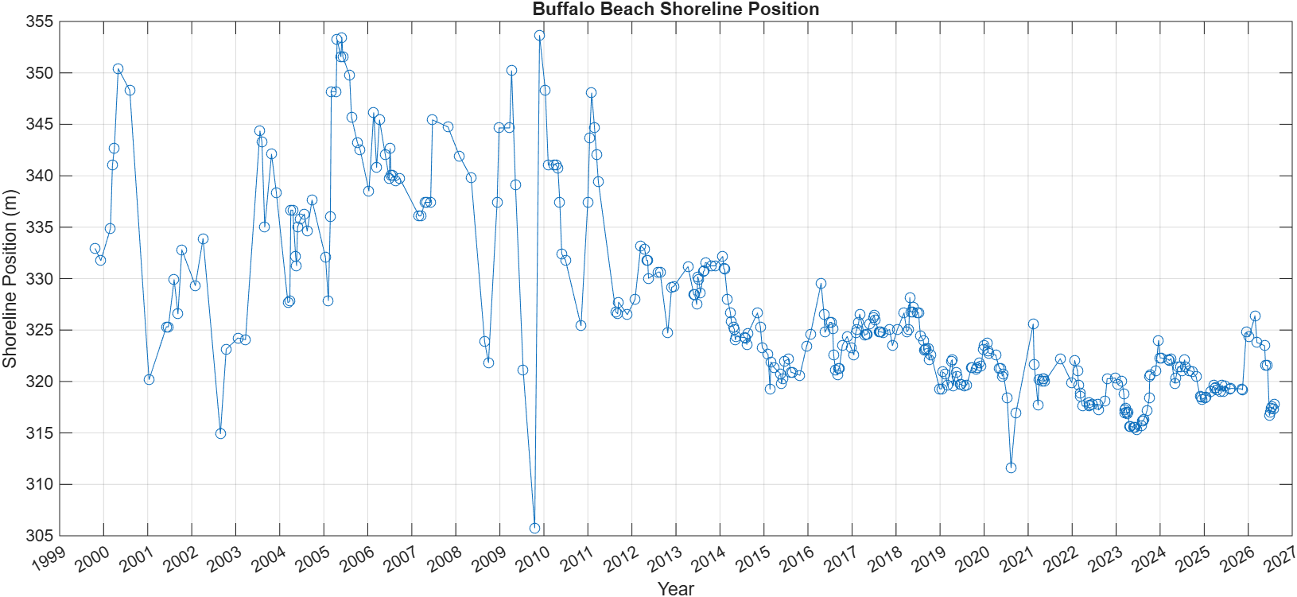
Figure 1. Transect 1, Buffalo Beach
Figure 1 illustrates the shoreline-position record at Transect 1 and its use in the modelling workflow. It shows whether that transect is generally eroding (downward trend), accreting (upward trend), or mainly fluctuating around a stable level. Results across all 42 transects are analyzed separately to capture spatial differences in shoreline behavior.

  - Historical shoreline change trends
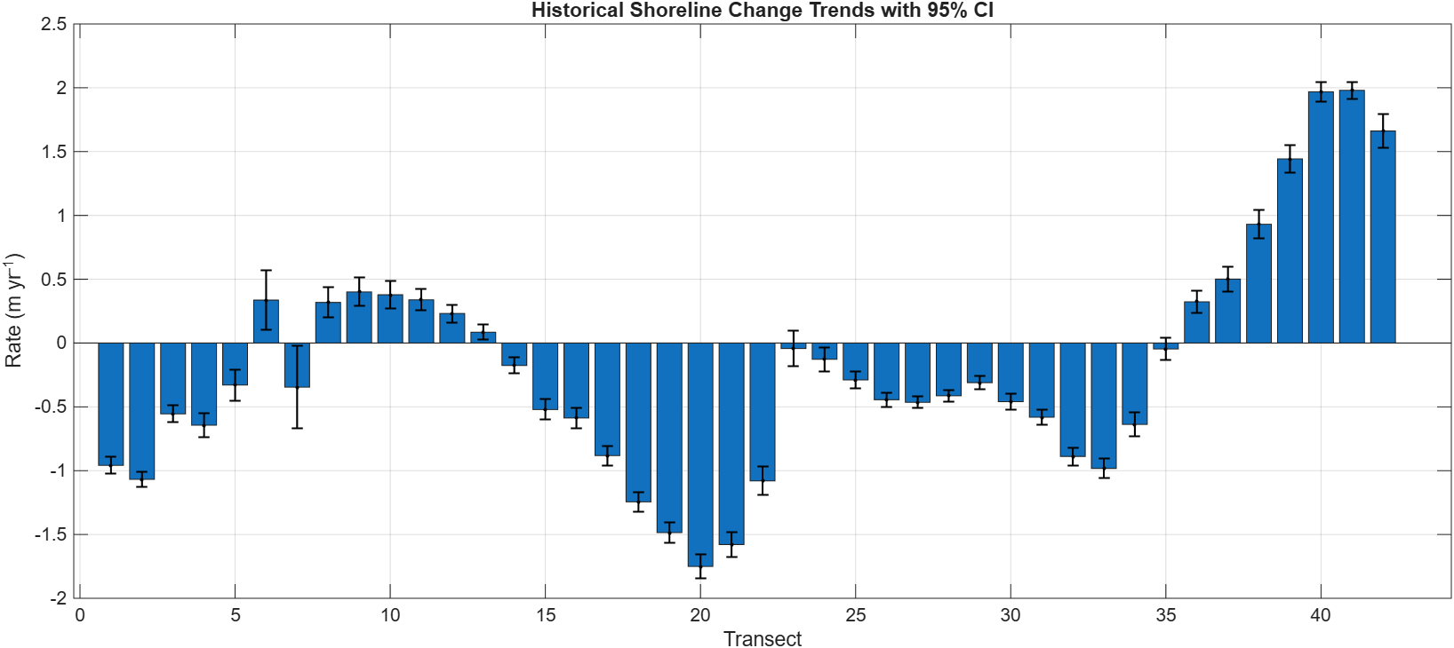
Figure 2. Historical shoreline change rates (m yr⁻¹) across transects 1-42, with error bars representing 95% confidence intervals. Negative values indicate shoreline retreat (erosion), while positive values indicate shoreline advance (accretion).
Buffalo beach coastline exhibits a predominantly erosional trend, with a mean shoreline change rate of −0.190 m yr⁻¹. The historical shoreline record shows clear spatial variability in shoreline behavior across transects. Some sections experience persistent erosion, while others are stable or accreting, so the coast does not respond uniformly. Erosion is most pronounced in the central sector, particularly at Transect 20, where the maximum retreat rate of −1.750 m yr⁻¹ was recorded. In contrast, the eastern sector exhibits strong accretion, peaking at Transect 41, where the maximum shoreline advance rate of 1.980 m yr⁻¹ was observed.
The Buffalo Beach Coastal Management Plan indicates that the sustained erosion in the central sector may have been driven by severe storms and high-energy waves, high tides and storm surges, natural sediment transport and coastal geomorphology, rising sea levels, and hard coastal structures that disrupt sediment movement and intensify erosion in adjacent unprotected areas. However, the marked accretion in the eastern sector suggests localised sediment accumulation and shoreline progradation. Most transects have relatively narrow 95% confidence intervals, suggesting statistical uncertainty in the estimated regression slopes but do not account for all potential measurement errors or changes in coastal processes. Consequently, trend estimates should be interpreted alongside data quality and observed shoreline variability when assessing the persistence of erosion or accretion.

  - Seasonal variability

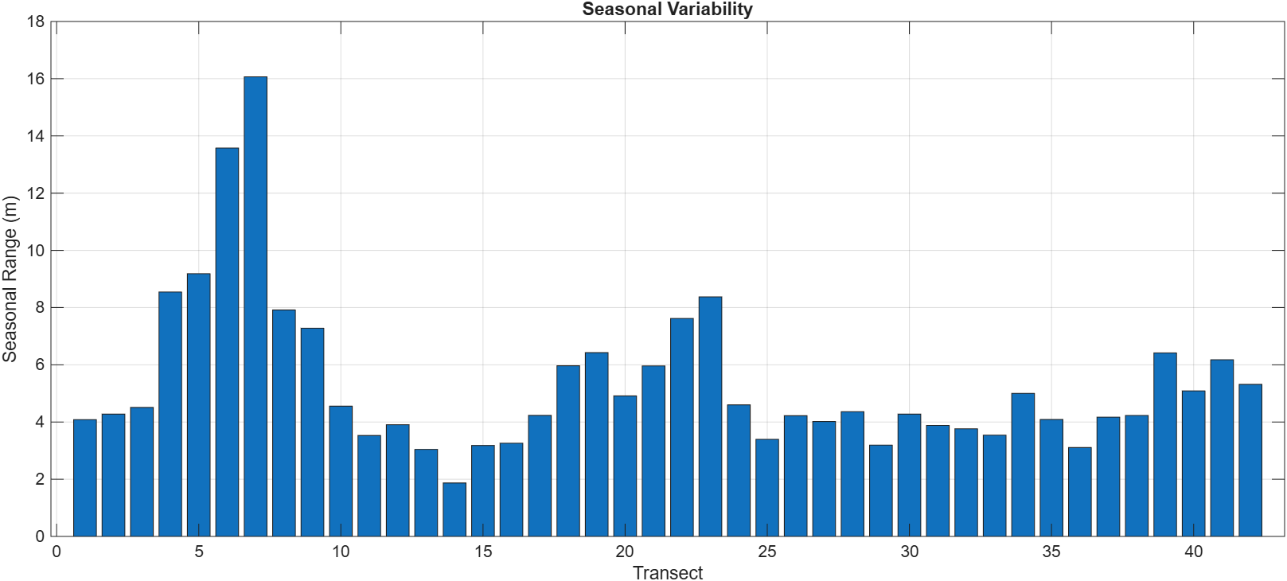
Figure 3. Seasonal shoreline variability across transects 1-42. Higher values indicate greater seasonal fluctuations in shoreline position, while lower values reflect more stable shoreline behaviour.
Seasonal shoreline variability ranges from approximately 1.9 to 16.0 m, demonstrating substantial spatial differences in short-term shoreline mobility. Most transects exhibit ranges of 3–6 m. Given the irregular survey intervals, these patterns indicate variability rather than definitive recurring seasonal cycles.
  - Interannual variability

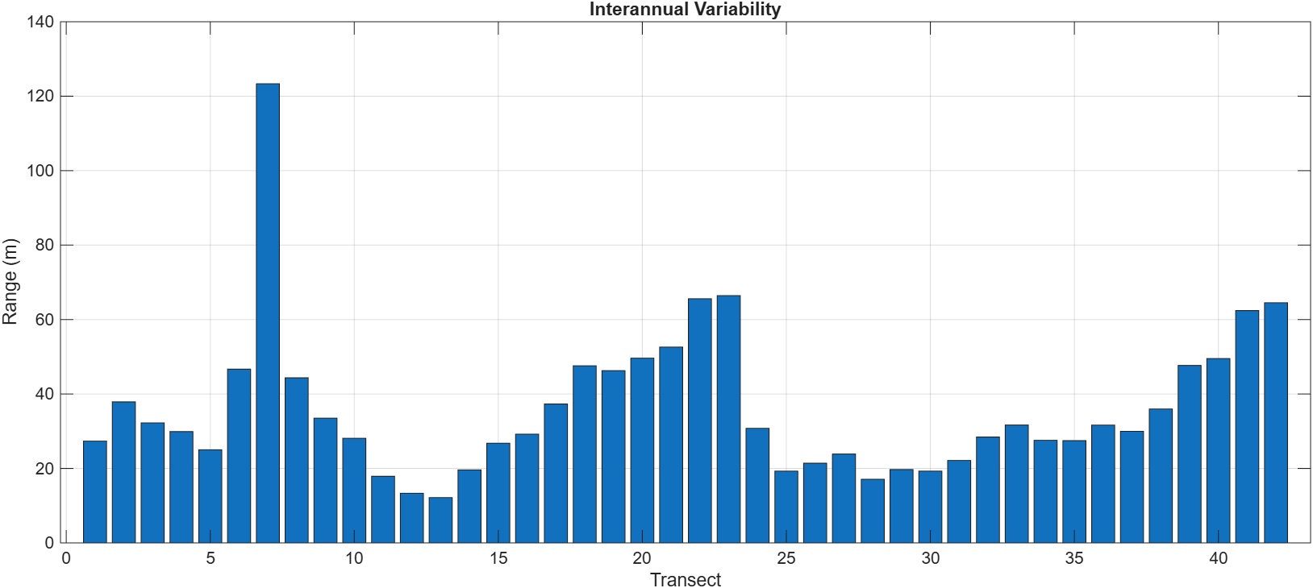
Figure 4. Interannual shoreline variability across transects 1-42. Higher values indicate greater long-term shoreline fluctuations, while lower values indicate relatively stable shoreline behaviour.
Interannual shoreline ranges from approximately 12 to 123 m, highlighting substantial spatial differences in longer-term shoreline mobility. These ranges quantify the magnitude of shoreline fluctuations but do not indicate the direction of change. They should therefore be interpreted alongside historical trend estimates to distinguish shoreline variability from sustained erosion or accretion.

  - Sensitivity to sea-level rise scenarios
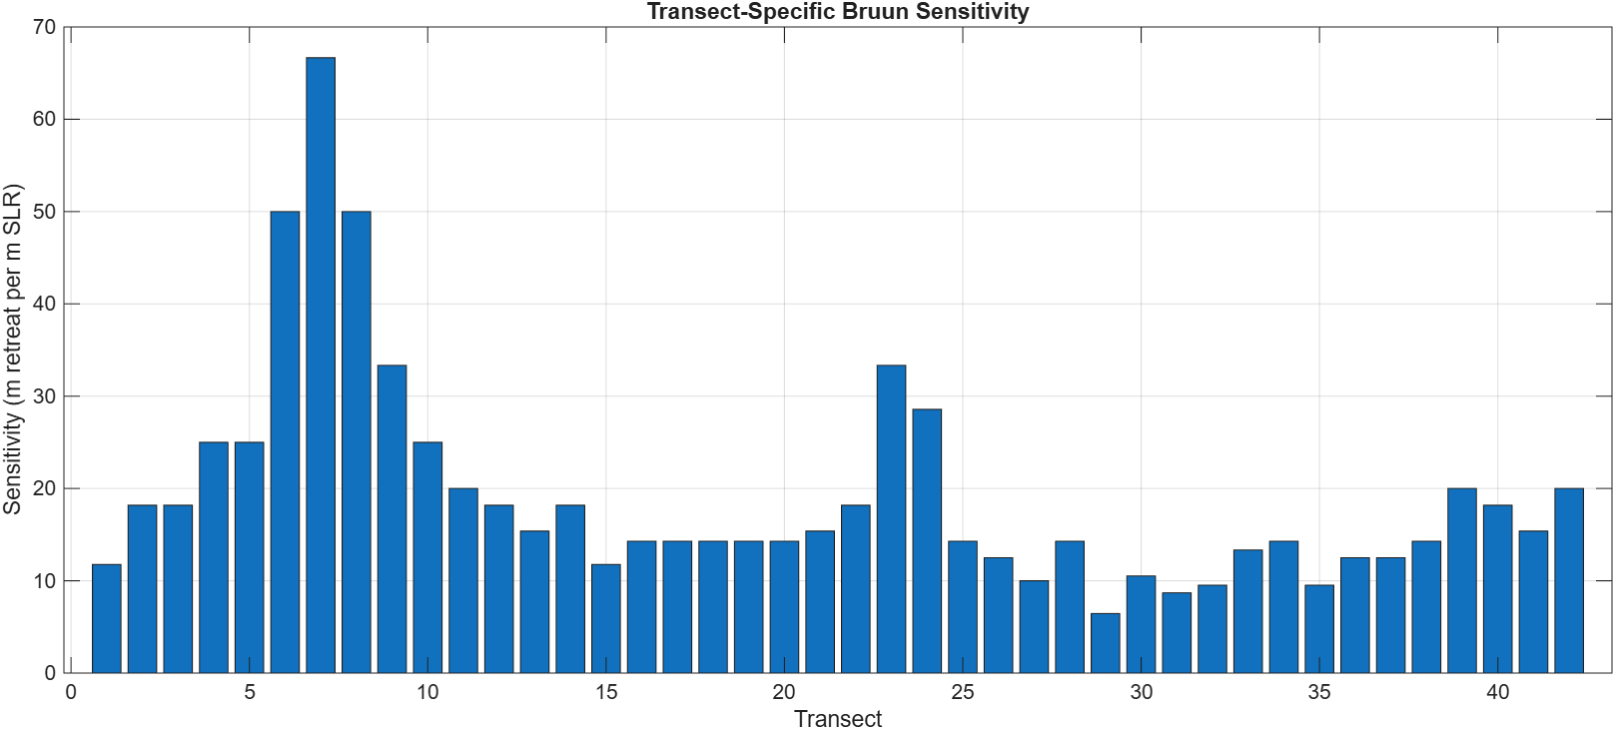
Figure 5. Sensitivity (m of shoreline retreat per m of sea-level rise) across transects 1-42. Sensitivity ranges from approximately 6.5 to 66.7 m m⁻¹ SLR, with the highest values occurring at Transects 6-8 and a secondary peak at Transects 23-24, indicating spatial variability in the projected shoreline response to sea-level rise.
The sensitivity analysis identifies Transects 6–8, particularly Transect 7, as the most susceptible to modelled retreat because of their gentler beach slopes. These areas may overlap with locations identified in an Environment Waikato Technical Report as potentially at risk, although spatial correspondence has not been established. Sight Consulting also highlights the influence of local coastal processes, reinforcing the need to consider both beach morphology and local dynamics in future hazard assessments.

  - Historical shoreline change vs. sensitivity
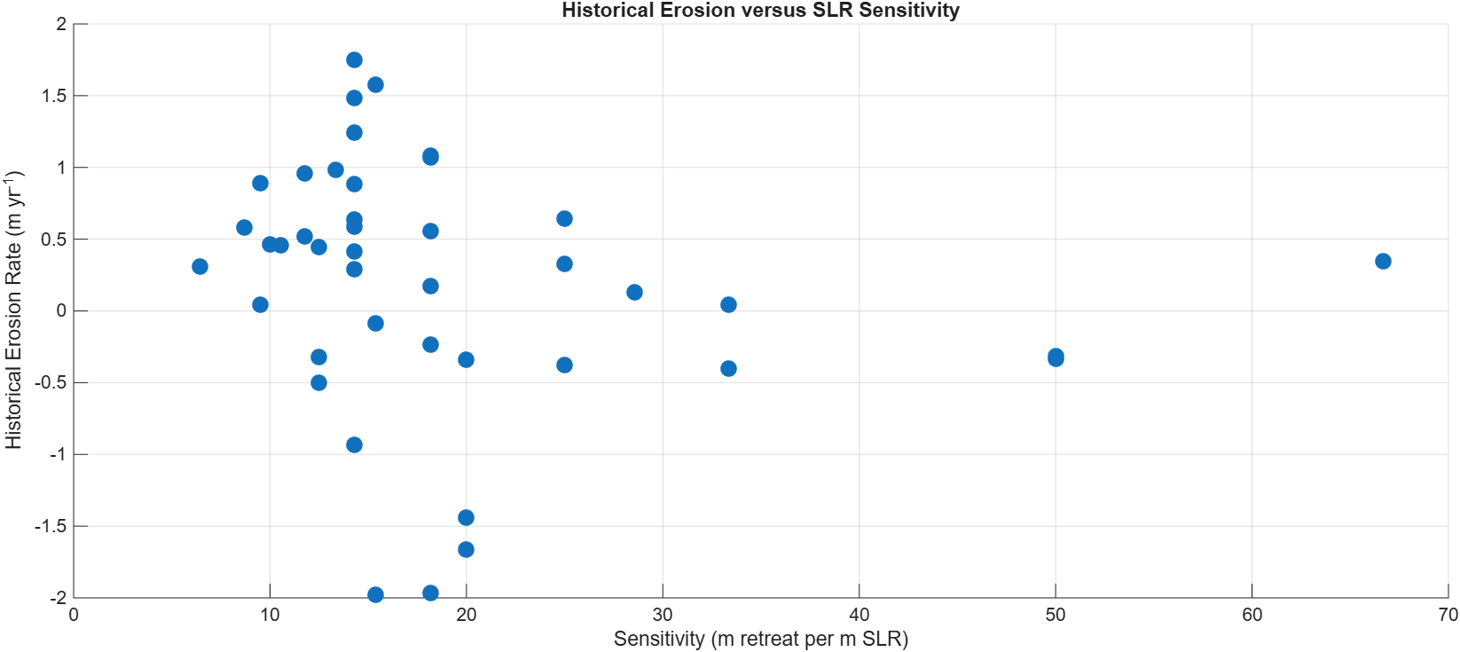
Figure 6. Comparison of historical shoreline erosion rates and sea-level-rise sensitivity across individual transects.
The scatter plot was used to examine whether transects with greater historical erosion were also more sensitive to sea-level rise. The analysis showed a weak negative correlation (r = −0.184); however, this relationship was not statistically significant (p = 0.2436). Consequently, there is insufficient evidence of a meaningful association between historical erosion rates and sea-level-rise sensitivity across the transects. This suggests that past shoreline behaviour may reflect the combined influence of local factors, such as wave exposure, sediment supply, beach morphology, storms, and human modification, rather than sensitivity to sea-level rise alone.
4.7 Projections of future erosions
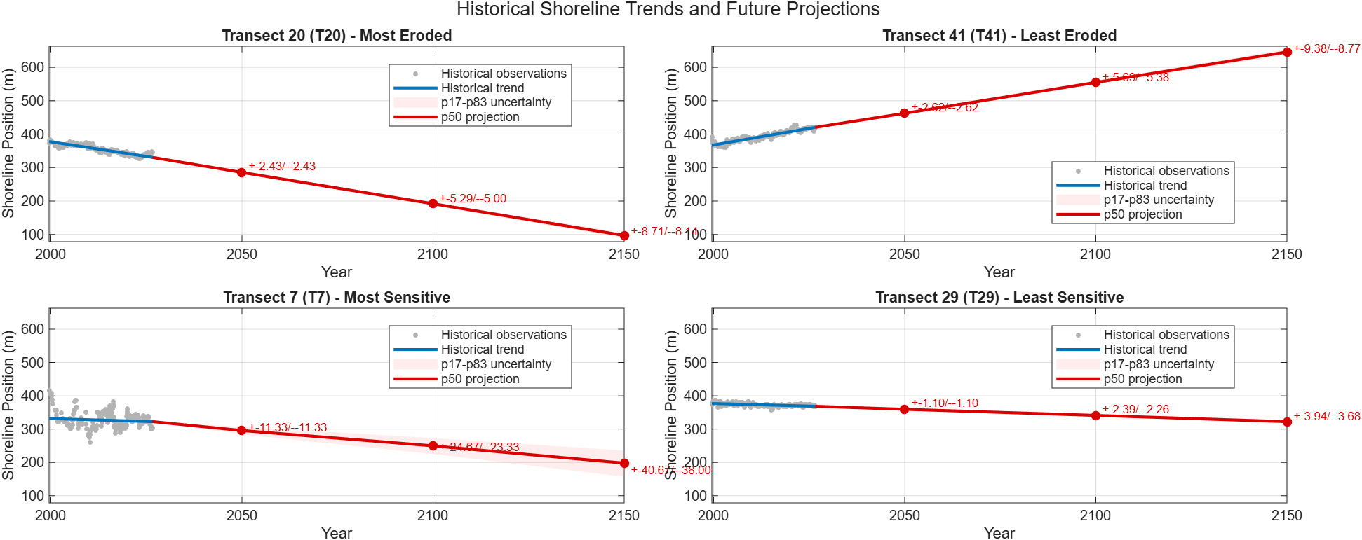
Figure 7. Projected shoreline positions at Buffalo Beach for 2050, 2100, and 2150 under sea-level rise scenarios (p17, p50, and p83). The p50 scenario represents the median projection, while the p17-p83 range indicates the uncertainty associated with future sea-level rise estimates. Shaded uncertainty bands reflect sea-level rise uncertainty only.
Future projections show substantial spatial variation in shoreline response. Transect 20 is projected to continue retreating, consistent with its historical erosion, while Transect 41 is projected to continue accreting. Transect 7 exhibits the greatest modelled sensitivity to sea-level rise (SLR), despite not having the highest historical erosion rate, whereas Transect 29 shows comparatively limited projected retreat due to its lower sensitivity.
These differences demonstrate that projected shoreline change reflects both historical trends and beach-slope sensitivity. This is consistent with the Waikato Coastal Database which highlights the influence of coastal morphology on shoreline response to SLR. However, the simplified Bruun-style model excludes important processes, including storms, wave climate, sediment supply, and human intervention. The projections are therefore indicative rather than precise predictions, and uncertainty in future shoreline positions should be considered when interpreting results over longer time horizons.
Areas experiencing substantial historical erosion and high modelled SLR sensitivity warrant particular attention in future monitoring and hazard assessments. However, high sensitivity alone does not establish future hazard severity, which also depends on local coastal processes and exposure. The results should therefore support the prioritisation of further investigation and coastal adaptation planning rather than be treated as definitive predictions of future shoreline positions.

- Conclusions and recommendations
The historical record indicates spatially variable shoreline change at Buffalo Beach, with a mean erosional trend of −0.190 m yr⁻¹. Transect 20 experienced the greatest historical erosion, while Transects 6–8 exhibited the highest modelled sensitivity to sea-level rise (SLR). These findings identify priority areas for further investigation and coastal monitoring.
Projections remain indicative due to uncertainty in shoreline data, beach slopes, SLR scenarios, and simplified model assumptions. It is recommended that the most eroded and SLR-sensitive transects be monitored more frequently, with the transect-based workflow retained for future updates to ensure comparability. Seasonal and interannual variability should provide context rather than substitute for long-term trend analysis. Projected retreat should inform planning and hazard assessment, not be treated as a final design value. Projections should be updated as improved shoreline observations, beach-slope measurements, and SLR estimates become available.
These recommendations will support the Council's ongoing coastal hazard assessment, land-use planning, and long-term adaptation decisions.

References

- Beca Carter Hollings & Ferner Ltd. (2006). Buffalo beach coastal erosion management strategy: Part 1 - Strategy. Environment Waikato. Environment Waikato Technical Report 2006/19.
- Cooper, G. G. (2003). Coastal hydrodynamics and shoreline change at Buffalo Beach, Mercury Bay (Master's thesis, University of Waikato). University of Waikato Library. https://www.waikatocoastaldatabase.org.nz/CoastalDataSet/Details/266
- NZ SeaRise Programme. (n.d.). Tākiwā map viewer: New Zealand sea-level rise and vertical land movement projections. Retrieved October 12, 2026, from https://searise.takiwa.co/map/6233f47872b8190018373db9/embed
- Sight Consulting. (2021). Buffalo Beach Coastal Management Plan (Report No. 9632). https://docs.tcdc.govt.nz/store/default/7050998.pdf
- SLR Consulting. (2020). Buffalo Beach coastal management plan. Prepared for Thames-Coromandel District Council. https://www.slrconsulting.com/projects/buffalo-beach-coastal-management-plan/
- Vos, K., Splinter, K. D., Harley, M. D., Simmons, J. A., & Turner, I. L. (2019). CoastSat: A Google Earth Engine-enabled Python toolkit to extract shorelines from publicly available satellite imagery. Environmental Modelling & Software, 122, 104528, from https://uoa-eresearch.github.io/CoastSat/#16/-36.8255/175.7062

